Professor’s Name
Student’s Name
Course
Date
Virtual Environments-Final Portfolio
Section 1: Brief Description
The Vatican museum, located just within the city boundaries of the Vatican City is an ideal place for an immense collection of cultural sculptures from the Renaissance period. The Renaissance period is amicably present in this museum as it contains more than 70 000 of works. Out of these, only about 20 000 are on display to any scholar interested in research. The museum's mission, vision, and specific goals are as follows:
Mission Statement
Committed to the reinstatement, preservation, and expansion of the collections and buildings of the Vatican City, while improving the acquisition and understanding of knowledge of members of the artistic work through meetings, visits, and lectures
Specific goals
- Spreading of knowledge of both cultural and spiritual dimensions to people.
- Restoration and promotion of different artistic work
- Facilitating the acquisition of new work from the existing collections
- Supporting expansion of an artistic design in future for the artists
Vision Statement
Art is an evangelization process which contributes to the beauty of the environment. By opening the museum to all, we aim at spreading the creative artistic nature of the previous man.
Section 2: Experience Design Components
Experience design is part of a conceptual design which focuses on human factors and other ergonomics to bring about the interaction between humans, machine, and the actual contextual environments to come up with systems which address experiences by users Moses and Christian 17). The user experience design will be the major component under discussion in this context, specifically, the visual design, interactive, usability and accessibility components.
With the application of the visual design components, visual elements such as images, color and symbols will be used to provide information to the audience about the Museum. Images of the actual sculptures and artifacts contained in the museum will be presented to the audience. Secondly, in the use of the interaction design, an essential part of the design will be achieved. This aspect will assist to focus the interaction between products and users thereby creating a product that is delightful in enabling users to achieve their intended objectives. In the close application of the component, interactive patterns will be best suited, besides conceptualizing the actual products to align with user anticipations. Finally, in the application of the accessibility component, the museum is strategically located such that it easy to reach, understand and use. In the general context, the museum system should be easy to use in the general context by a vast number of people (Moses and Christian, 18).
In a close application of these components, it will be easy for members to improve their knowledge of artistic design. The crucial component accessibility will provide room for the intended people to access the structure in a virtual and real physical environment, therefore enabling the attainment of the set goals.
Part 3: location and Target Demographics
The target population for this design is the historic and artistic scholars interested in expanding their knowledge about the ancient history. The location of the Museum is at the edge of the Vatican City. This is a very potential place and serene environment for all people across the globe. The fact that the design puts into consideration both the interactive, accessibility and visual design components provides an opportunity for the access by the target people. The ability to incorporate images, pictures and other components (as discussed above) align the features with the demographic aspects. The museum aims at enriching scholars, across the geographical divides about the human history. A clear selection of Experience Design Components has been developed to ensure that all people have aces to the facility.
Section 4: Marketing Materials Designed
To ensure that the specific goals are achieved within the set period, the Vatican Museum has adopted specific marketing materials. The most important once are the brochures, which have been developed and circulated in the social media platforms such as Facebook and Twitter. Major brochures of the year designed are given below:
Image 1
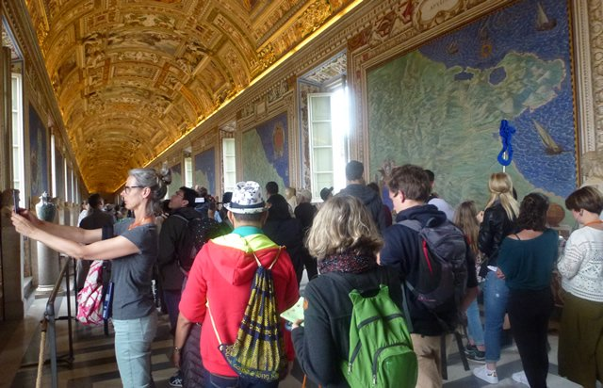
Image 2
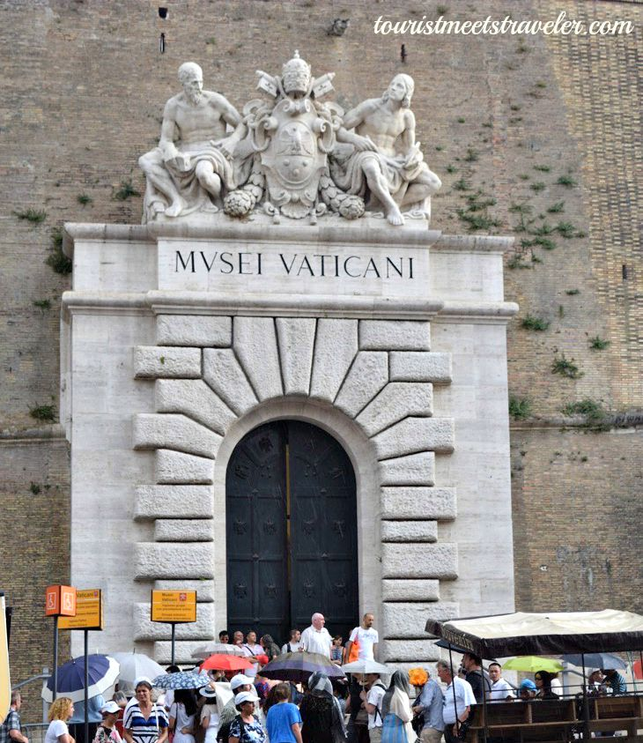
The social media marketing platform has been the major point of focus of the Museum. A website ‘www.Vaticanorg.Museum” was put in place to provide room for consultation as well direction to people about where exactly it is located. Finally, press releases have been adopted as another marketing strategy.
Section 5: compiled research
The Vatican Museum was constituted in 1447 by Pope Niccolo. In 1471, the artistic culture was enhanced when Sixtus IV ordered the construction of new structures with numerous decorations. Most of the ancient decorations were done by Sandro Botticelli in assistance of Pietro Perugino. At this time in history, the museum contained only private works by Julius II. Currently, the museum's outlook is extremely different. Inside the museums are numerous collections that have been collected by the Popes over the years. Amicably, the museum has a great masterpiece of an artistic culture which represent the actual historical eras. Besides, it should be understood that the museum contains collections from art, ethnology, and archeology which captures the historical as well as artistic cultures of the people (Andrén and Arvid, 1940). Currently, the Vatican museums have more than four different routes which make it accessible to people visiting different galleries. This has made it possible for many people (about six million) to potentially visit the Museum. Consequently, in the use of brochures presented in the social media, adoption of the marketing tickets and travel guides has contributed to the popularity of the museums.
Section 6: A Reflection Paper
Experience is rooted in conceptual design, human factors, and ergonomics. The elements and components of experience design demonstrated by my project are those correlated with the user experience. More specifically are the Usability, Accessibility and visual design components. The visual design components demonstrated by my project are not limited to those related to visual communication, user interface, and graphic design. It focuses on the use of visual design to convey messages to the respective audiences, who in this case are the scholars of history. The fact that the museum has numerous artistic and sculptures ensures that it meets the graphics as well as communication design. As discussed in the context above, my museum puts into consideration both the visual perception, Gestalt's psychology and cognitive psychology to bring about the effective communication strategies. Consequently, the fact that the Vatican museum is easy to reach, use as well as understand makes use of the accessibility component of the Experience design. My project is well related to comprehension of the overall features. Finally, with the fact that my project achieves the interaction between the products and the others means that it achieves the interactive design, which is also another important content of the experience design. Therefore, as demonstrated in the context above, it is basically true that my project illustrates the current application of practices common in experience design.
Throughout the learning process, I have learned a lot concerning Experience design. Experience design is a practice or process of coming up with products, events, services, processes or environments whose focus is on the quality of culturally relevant user experience solutions (Tussyadiah and Lis 551). This discipline is related to other fields such as cognitive psychology, cognitive science, perceptual psychology and technical communication. There is three main context through which Experience Design considers; the commercial context, broader context, and the multiple dimension. It may also assume the marketing by identifying existing touch-points in the market or creating new once (Pullman, Madeleine and Gross 562). Besides, in every domain, technology, content, and design are always the focus points as demonstrated below.
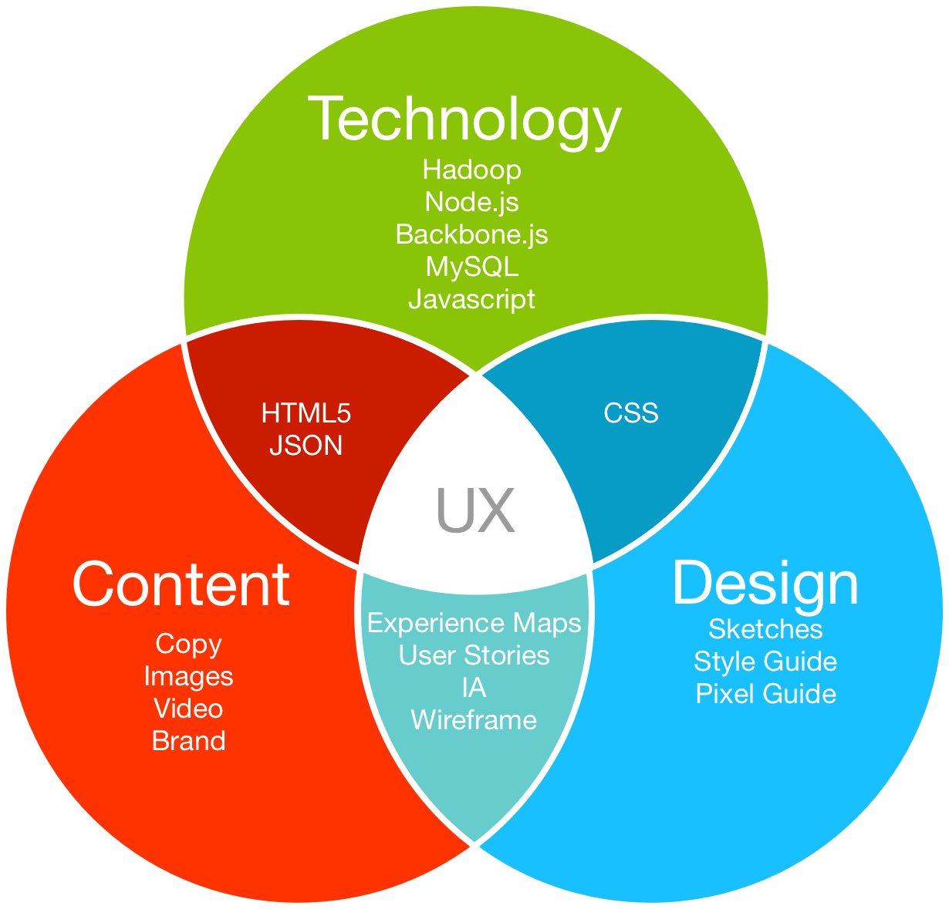

Works Cited
Andrén, Arvid. Architectural terracottas from etrusco-italic temples. Gleerup, 1940.
Moser, Christian. "User experience design." User experience design. Springer, Berlin, Heidelberg, 2013. 1-22.
Numerico, Teresa, Jonathan P. Bowen, and S. Filippini-Fantoni. "Search engines and on-line museum access on the Web." Museums and the Web 2005: Proceedings, Toronto: Archives & Museum Informatics (2005).
Pullman, Madeleine E., and Michael A. Gross. "Ability of experience design elements to elicit emotions and loyalty behaviors." Decision Sciences 35.3 (2004): 551-578.
Tussyadiah, Iis P. "Toward a theoretical foundation for experience design in tourism." Journal of Travel Research53.5 (2014): 543-564.

Section 8: Blue Prints and 3 D Computer Graphics of the Vatican Museum
